Experiment-7

Aim:Simulation of different topologies and packet transfer between nodes
Objective:
To design, configure, and simulate various network topologies (such as star, bus, ring, and mesh) using Cisco Packet Tracer, and observe packet transfer between nodes to understand how network structure affects data flow, efficiency, and communication reliability.
RESOURCES REQUIRED
- Software: Cisco Packet Tracer (version 8.0 or later)
- Devices (Virtual):
  - 4–6 PCs (end devices)
  - 1–2 Switches (Cisco 2960)
  - 1–2 Routers (optional, for inter-network communication)
- Cables:
  - Copper Straight-Through Cables (for PC-to-switch connections)
  - Copper Cross-Over Cables (for switch-to-switch or PC-to-PC in bus topology)
- Tools:
  - Packet Tracer Logical Workspace
  - Packet Tracer Simulation Mode

Theory:
Network topology refers to the arrangement of devices (nodes) and connections in a computer network. Understanding different topologies is essential for designing efficient, reliable, and scalable networks. Each topology has distinct characteristics that affect performance, reliability, and fault tolerance. In practical experiments using network simulators like Cisco Packet Tracer, we can visualize how data packets move through these topologies, analyze network behavior, and observe the impact of device or link failures.
Types of Network Topologies:
- Star Topology:
Structure: All devices are individually connected to a central node, typically a switch or hub.
Advantages:
Easy to install, manage, and troubleshoot.
Failure of a single device does not affect others.
Disadvantages:
Central device failure results in network downtime.
Requires more cables compared to bus topology.
Packet Transfer: Data from one device passes through the central node before reaching the destination. In simulation, you can observe that all packets are directed to the switch, which then forwards them appropriately.
- Bus Topology:
Structure: All devices share a single communication line (backbone).
Advantages:
Simple design and cost-effective.
Requires less cabling than star topology.
Disadvantages:
A fault in the main cable can disrupt the entire network.
Performance decreases as more devices are added.
Packet Transfer: Packets are broadcast along the bus and received by all devices. In Packet Tracer, you can see collisions occurring if multiple devices attempt to transmit simultaneously, affecting efficiency.
- Ring Topology:
Structure: Each device connects to exactly two neighbors, forming a closed loop.
Advantages:
Reduces packet collisions due to unidirectional data flow.
Data flows predictably along the ring.
Disadvantages:
Failure of a single device can disrupt the entire network unless a dual ring or bypass is used.
Packet Transfer: Packets travel sequentially from one node to the next until they reach the destination. Simulation helps visualize the circular path of data.
- Mesh Topology:
Structure: Each device is interconnected with multiple paths to other devices.
Advantages:
Highly reliable and fault-tolerant; multiple paths ensure communication even if one link fails.
Reduces the chances of network congestion.
Disadvantages:
Complex to configure and maintain.
Expensive due to large cabling and port requirements.
Packet Transfer: Packets can take multiple routes to reach the destination. Packet Tracer allows you to simulate different paths and observe network redundancy in action.
Packet Transfer in Networks
Definition: Packet transfer is the process of sending data between devices in the form of packets.
Role of Simulation: In tools like Packet Tracer, packet transfer can be monitored to observe:
How packets traverse different topologies.
Whether packets are flooded (broadcast) or sent directly (unicast).
The effect of device or link failures on network performance.

PROCEDURE →
A. Star Topology Procedure
- Open Cisco Packet Tracer and create a new workspace.
- Add 4 PCs (PC0–PC3) and 1 switch. Arrange the PCs around the switch.
- Connect each PC to the switch using straight-through cables.
- Assign IP addresses:
PC0: 10.0.0.1
PC1: 10.0.0.2
PC2: 10.0.0.3
PC3: 10.0.0.4
- Use subnet mask 255.255.255.0 for all.
- Verify that all link indicators are green.
- Test connectivity by pinging all other PCs from each PC.
- Switch to Simulation Mode and use the Add Simple PDU tool. Observe that the switch forwards packets directly to the destination PC.
- Optionally, configure the switch using CLI for management purposes.
Ensure all devices communicate successfully and note the packet paths.
B. Bus Topology Procedure
- Open Cisco Packet Tracer and create a new workspace.
- Add 4 PCs (PC0–PC3) and arrange them in a straight line.
- Connect all PCs using a single shared bus cable.
- Assign IP addresses:
PC0: 10.0.0.1
PC1: 10.0.0.2
PC2: 10.0.0.3
PC3: 10.0.0.4
- Use subnet mask 255.255.255.0 for all.
- Verify all link indicators are green along the bus.
- Test connectivity by pinging all PCs from each PC.
- Switch to Simulation Mode and observe that packets travel along the bus and are received by all devices.
Ensure all devices communicate and note any collisions or delays in packet transfer.
C. Ring Topology Procedure
- Open Cisco Packet Tracer and create a new workspace.
- Add 4 PCs (PC0–PC3) and arrange them in a circular layout.
- Connect each PC to two neighbors using straight-through cables to form a closed loop.
- Assign IP addresses:
PC0: 10.0.0.1
PC1: 10.0.0.2
PC2: 10.0.0.3
PC3: 10.0.0.4
- Use subnet mask 255.255.255.0 for all.
- Verify that all link indicators are green and the ring is complete.
- Test connectivity by pinging all PCs from each PC.
- Switch to Simulation Mode and observe that packets travel sequentially through intermediate PCs until they reach the destination.
Ensure all devices communicate successfully and note that a single device failure can disrupt the network.
D. Mesh Topology Procedure
- Open Cisco Packet Tracer and create a new workspace.
- Add 4 PCs (PC0–PC3) and arrange them in any layout.
- Connect each PC to every other PC using straight-through cables.
Assign IP addresses:
PC0: 10.0.0.1
PC1: 10.0.0.2
PC2: 10.0.0.3
PC3: 10.0.0.4
- Use subnet mask 255.255.255.0 for all.
- Verify all link indicators are green.
- Test connectivity by pinging all PCs from each PC.
- Switch to Simulation Mode and observe that packets can take multiple paths to reach their destination, providing redundancy.
Ensure all devices communicate successfully and note the reliability of multiple paths.

Simulation
- Star topology
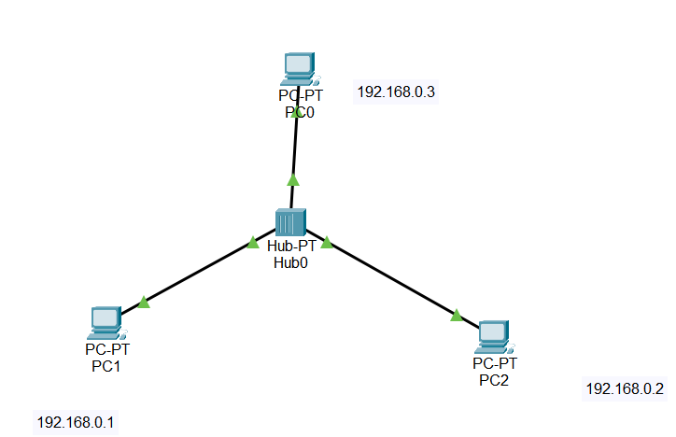
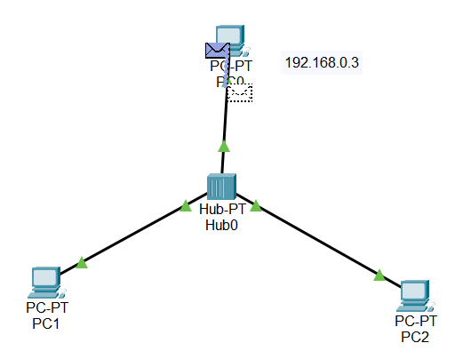
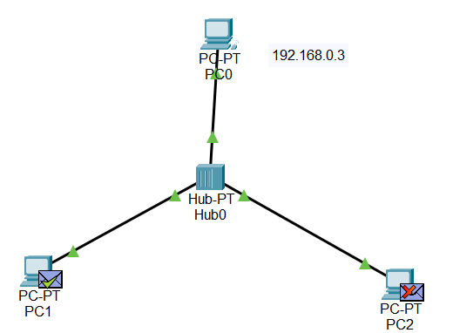
- Mesh topology
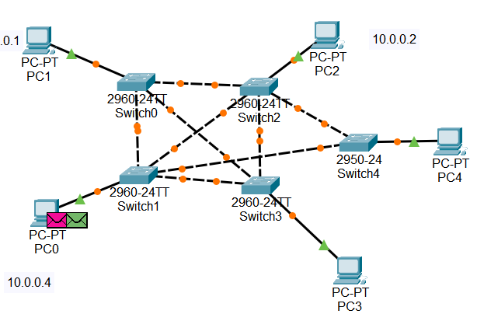
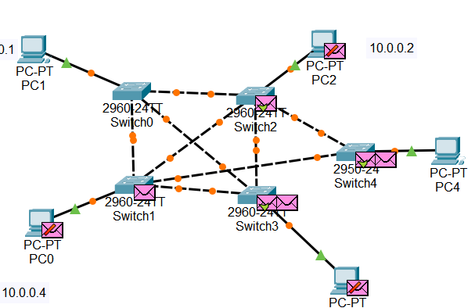
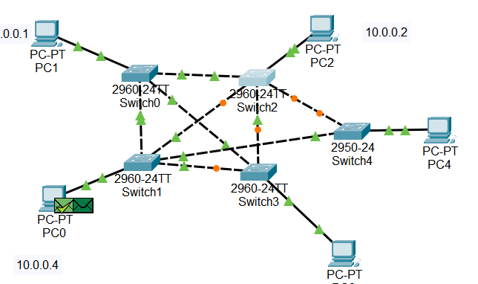
- Bus topology
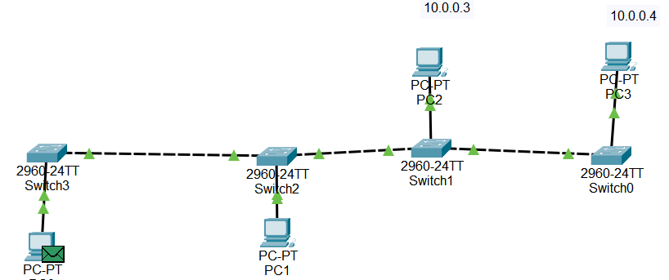
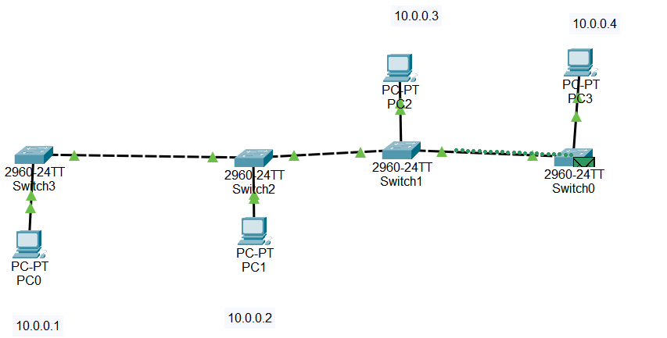
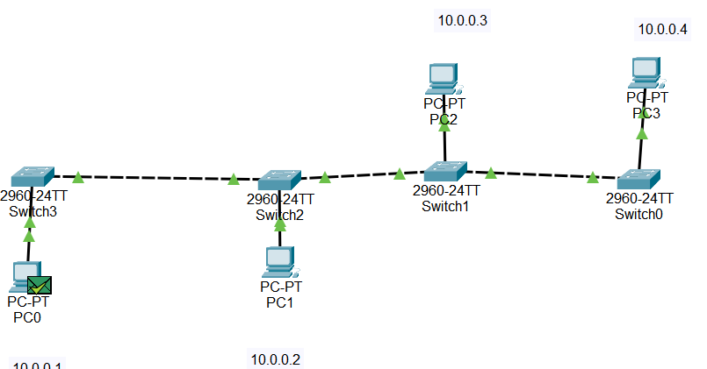
- Ring Topology
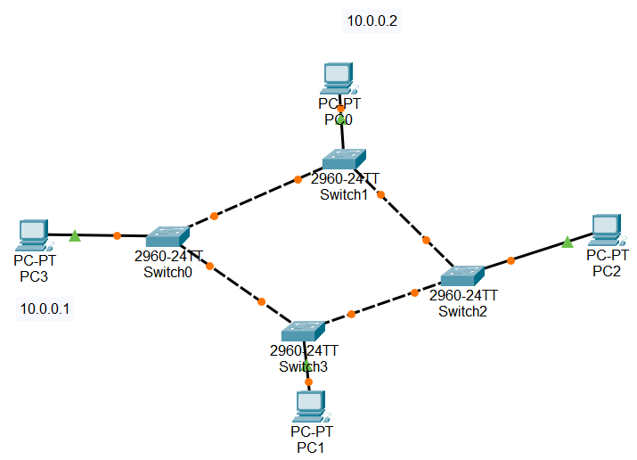
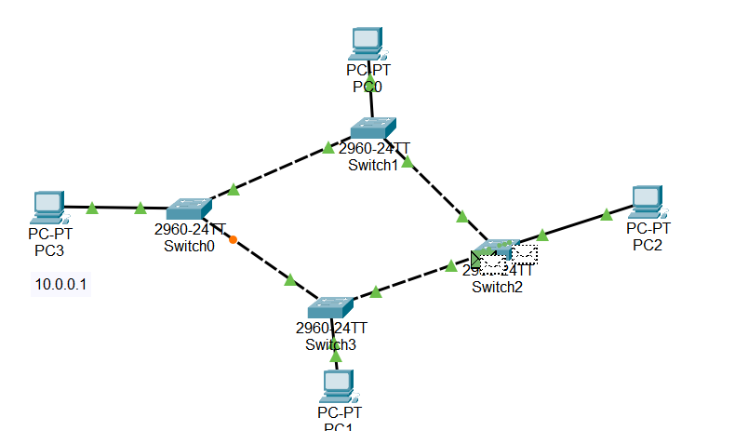
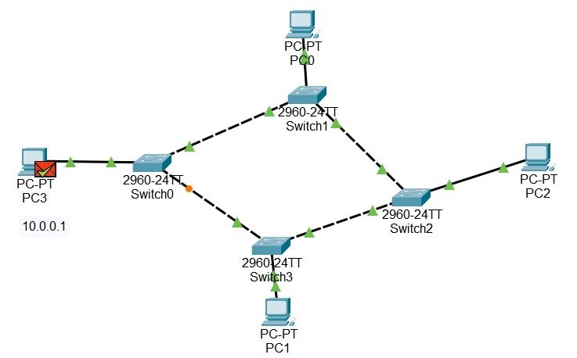

Result / Conclusion:
Different network topologies were successfully simulated in Cisco Packet Tracer and observations were made on how different topologies transfer packets differently.

